1. ALL takings of all forms of private and "public" property are connected.
- We have been indoctrinated into believing all forms of taking property sanctioned by banks and government are legitimate
- Individual takings are connected to the other takings, i.e. all takings are connected
- This is neither accident nor random nature of man or Mother Nature.
- The current system we live in, destroys property by creating usury, debt, regulation & tyranny
- When each of us understands how the "American" and world banking systems work, this truth will be self realizing, i.e.
  - America and the world is enslaved by the current system as the video above describes
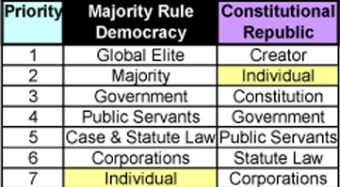

2. The current system is a mirror image of an incomprehensible massive multi-national and global banking and monetary racket.
- Global cartels hold the world in a strangle hold of criminal agencies using usury, debt and regulation, i.e. tyranny
- This is done through geographical, intellectual, political, financial, educational and monetary fractionalization
- We are deceived to take sides where the cartels win and we lose
- This system of smoke and mirror and lies, is funded by our printing presses in America and some 60 countries in the world
- The natural born state Citizens are not responsible for any government debt at any level, i.e. city, county, state, union of states
- There are NO higher laws and acts of the land that so degree

3. How did power, blood lines and divine rights come to oppress us today?
- "Government" is a network of municipal corporations controlled by tribunals & cartels which are not elected and invisible.
- Municipal corporations originated in British monarchy
- British and European feudal history bestowed "divine rights" upon certain blood lines
  - Not unlike religious hierarchy
- The self proclaimed "divine rights" of kings, queens and religious human elite still exist today
- This ideology of "divine rights" of a blood line passed through the ages into all levels and forms of current "government" infrastructure and charters ( “good and bad charters”)
- It was written into our own united States of America constitution when you have the eyes to see
- The missing 13th Amendment tried to take out nobility written into the Constitutions, e.g. lawyers, bankers, rich elite
- Current constitutions give public servants certain "divine rights" which were never bestowed on them willingly, by natural born Americans, e.g.
  - Immunity and impunity,
  - Taking and exceeding power never rightfully given,
  - Assumptions of unalienable/birth rights
  - nobility, status, title, high office, arrogance,
  - over 80% (more like 95%) of all levels of government power is illegitimate
  - natural born Americans would never give away such power to war upon themselves & their sacred individual sovereignty & unalienable rights
- The blood lines and “divine rights” were false titles of nobility bestowed by the benefactors for power and profit
- These are ancient ritualistic symbolism created for profit and power
- The benefactors concocted the blood lines, divine rights for power
- The benefactors convened the courts, kingdoms and charters to secure their family lineage, associations in perpetuity
- Over history all charters mirrored this “divine right” symbolism
  - i.e. the symbolism was NEVER lost in all societies through time
- The state constitutions wrote in municipal corporations
- "Public municipal officials" are given and act upon feudal divine powers inherently bestowed in US and state constitutional charters
- If America had lost the first revolution we would be held under a monarchy
- We were freed from this slavery by the highest laws and acts of America, in name only,
- The intent of freedom and liberty was undermined by dark forces
  - Much more deceptive than the American natural born
- Current form of so called “constitutional government is by NO CONSENT
- General Washington and the remaining 2000 starving, freezing men won the battle and instantly lost the war
- Current form of "electing and voting" is much like a proxy vote for private corporation board members.
- Few to no public officials, nor most of the fiefdom, understands this history, nor would most acknowledge it, if they were told
- The board, i.e. cartels, muni associations, UN, etc., decide who they want you to vote for - then
  - the proxy is sent out to the "shareholders"
  - of the candidates they give you to choose.
- Whoever is "elected" comes onto the "boards/councils/mayors, house, senate, executive, judiciary, etc.”
  - i.e. city, county, state, union of, are compelled to operate under the above corrupted ideology
- All state constitutions are corrupt and are not constitutional republic charters at all
  - so called constitutions are muni corporation bylaws
- You may say municipal corporations are private nonprofit corporations
  - whose board, management and employees are given levels of "divine power"
- Private corporations and prominent attorneys highly influence, i.e. control,
  - the territorial to state constitutional conventions and THEIR "constitutions"
- You can also say the private corporations and the public corporations are “new age” feudal state and church forms of control, i.e.
  - They give themselves the power and authority to rule
  - Which is the equivalent of the “divine rights” bestowed via feudal war lords and other tyrannical forms of self imposed “divinity authority” and "nobility"
  - i.e. they rule by self bestowed “divine rights” using tyranny
- The system in place today we call “government” is strictly forbidden by the highest laws and acts of America, i.e.
  - the Laws of Nature and Nature's God,
  - the Declaration of Independence and
  - the act and success of the American Revolution
- More on this coming out soon, there is NO question the American constitutions are cooked

4. Even true and honest constitutional republic governments do NOT create or produce anything of free market value
- NO form of "government", monarchy, tyrannical hierarchy is economically viable
  - Even a so called "limited government" is NOT a stable system
    - i.e. any system of “government” is NOT stable if it uses force
  - I.e. there is no stability in society until that society becomes advanced enough to “require” no government.
- All forms of "Government" operate by theft and tyranny
  - Selling debt and forcing its payment by stealing property from its citizens
  - Warring upon its neighbors and transferring its citizens and goods into slavery for the "winner"
- Governments mirror the central banks because:
  - the banking - government relationship is not unlike the church - feudal monarchy/fiefdoms
  - both institutions create a false ideology by brokering power that is rightfully, naturally and divinely belongs to the individual
- If a society "needs" structure in a true and honest limited government in America, the true and honest mission is:
  - assure all our 70 some unalienable rights of the natural born are upheld and protected
  - assure the sovereignty of the natural born is upheld
  - assure complete and absolute independence of the several states
  - assure the free market reminds absolute free and competitive
  - assure America is not entangled in any foreign affairs and wars, including affiliations with central banking
  - assure our borders are completely protected
- As societies advance, they require less government
- "Enlighten societies" do not need government
- The intent of a limited government for American society while "sincere" never happened
- Urantia Book material is a real eye opener along this line - Most profound.

5. Property and wages of the state Citizens are the only true and honest value of the land
- Here are the gifts given to sovereign natural born American's at birth
  - http://www.freedomforallseasons.org/NaturalLawAndNaturalRights.asp
- This is how all of our rights were taken
  - See attached Excel Spread Sheet - USA Debt History
  - Without free people and our property and labor, the printing press have no value
  - Without free people, true and honest value does not exist
  - Conversely, when free people are enslaved, there is no value, i.e. only usury, debt, regulation and tyranny & wars
  - When love and free choice are strangled out of a society, tyranny flows in

6. Governments do not represent free people nor can any human represent the free & sovereign natural born state Citizen
  - a true and honest natural born state Citizen is a free agent whose allegiance (by free choice) is toward their God NOT government
  - a true and honest "government", if one is needed, cannot sanction itself, bestow itself or force itself upon those who created it
  - Free individuals cannot be forced into a "representative" system for many reasons:
    - it is statistically impractical and highly inaccurate to "represent" anyone let alone large groups of free and independent people
    - Free people are not widgets or ball bearing which CAN be sampled
    - High levels of quality control of inanimate objects can be maintained using statistical sampling
    - While attributes of free people like behavior, health, education, jobs, etc., may be accurately sampled through polls by free choice -
      - INDIVIDUAL FREEDOM AND LIBERTY AND UNALIENABLE RIGHTS CAN NEVER BE REPRESENTED OR SAMPLED
      - INDIVIDUAL FREEDOM, LIBERTY AND ALL UNALIENABLE RIGHTS ARE UNTOUCHABLE DIVINE RIGHTS GIVEN THROUGH BIRTH
    - Government cannot represent free individuals unless that person freely gives up his rights
        - Even when a natural born who freely surrenders their sacred rights cannot be taken advantage of, i.e. their property cannot be taken or regulated in anyway
  - It is an oxymoron that a nation, state, county or city can represent a free people, because:
    - The act of "representing" corrupts the freedom of the individual in dishonest societies, e.g. America.
    - American society is not advanced morally to a stage where a "representative government" can work
    - Sovereign free and independent natural born cannot be compromised by transferring their divine power to another,
      - i.e. who is more qualified to represent your birth rights?
    - Even true and honest limited government societies,
      - would never interfere with personal affairs of the natural born
    - The natural born are the masters, the sons and daughters and the kings and queens of the land
      - They are divine and above all courts, legislature and executive branches because -
        - The natural born have the power to nullify all the laws of the land and judge and free anyone
        - With the power of the jury of their peers
        - Where peers are friends and associates who know them well
        - NO free natural born would ever knowingly give up their birthrights
      - Current courts and juries are an abomination of true and honest trial by jury and grand juries
    - To bind or take or "represent" or regulate a natural born state Citizen is to destroy their freedom and liberty

      - by trial and error
      - Given this nature of the higher spiritual beings and natural laws of our land
        - One human or groups of humans cannot "represent" the American natural born
        - i.e. you cannot “represent’ those who create you
        - America is not a democracy because of this fact
      - America is a individual controlled Constitutional Republic in a true and honest society
      - Limited governments DO NOT REPRESENT FREE STATE CITIZENS
        - THEY ONLY PROTECT THEIR UNALIENABLE RIGHTS
      - Limited governments ARE LIMITED TO VERY NARROW AFFAIRS NEEDED BY SOCIETIES AT OUR STAGE OF GROWTH TO PROTECT INDIVIDUAL FREEDOM & LIBERTY …
        - I.E. NOT TAKE THEIR FREEDOMS & LIBERTIES IN ANYWAY

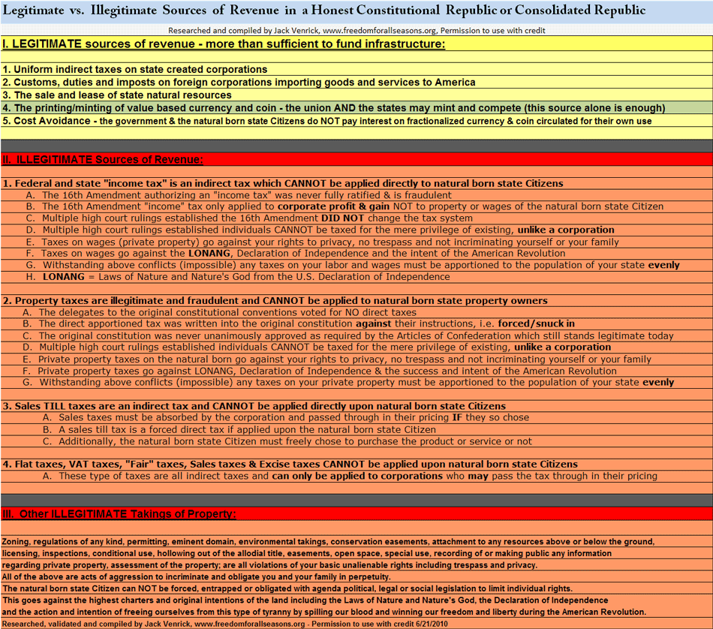

6. All interest, taxes, regulation and any other form of taking life, liberty and property upon the American Natural Born state Citizen is:

- Absolutely unnecessary, criminal and prohibited by the Higher Laws and Actions of the Land and repeated high court rulings, e.g.
  - the Laws of Nature and Nature's God,
  - the American Declaration of Independence and
  - the success and intent of the American Revolution
  - Existing high US court rulings ( which have been ignored)
- http://www.freedomforallseasons.org/FreedomFromTaxesNew.dwt.asp
- The constitutions (U.S. and several states) were never given the power or authority to take any property of the people
  - Much of the centralization of power in the union, states, counties and cities go against all of the above higher laws of the land
  - American "government" was and is mirrored in large part from feudal British political and banking ideologies
  - Even the intent of the Founding Federalist is increasing be challenged by credible researchers
  - Another way to say this is, all the constitutions are full of conflict and do not thread to the higher laws and acts of the land
  - This is why the current form of American "government" actively mirrors British and European feudal monarchial systems
  - We are taught to believe we have a constitutional republic with separation of powers and a participatory government
    - This is a lie, perpetrated from ignorance, deception and apathy
- Much more coming out on this soon in a Web Site Documentary on how the State of Washington constitution has been cooked
- You can read how the U.S. constitution convention & resulting constitution was corrupted here
  - http://www.freedomforallseasons.org/ConstitutionThatNeverWasNew.asp

